LAB TEST 4

Question 1: AI-Assisted Data Cleaning
Task:
You are given a raw dataset named health_data.csv containing missing values, inconsistent text entries,
and duplicate rows.
Use an AI-assisted coding tool (e.g., ChatGPT, GitHub Copilot, or Google Gemini) to generate a
Python script that:
1. Detects and removes duplicate rows.
2. Handles missing values using appropriate techniques (mean, median, or mode).
3. Standardizes inconsistent categorical data entries (e.g., “Male”, “male”, “M”).
Instructions:
• Verify that the dataset is clean by displaying the first 5 rows before and after cleaning.
• Document which AI suggestions you used and how they improved your code.
CODE:
import pandas as pd

# Load the dataset
df = pd.read_csv('/content/health_data.csv')
original_df = df.copy() # Create a copy for comparison

# Detect and remove duplicates
print("Number of duplicate rows before removal:")
print(df.duplicated().sum())
df.drop_duplicates(inplace=True)
print("\nNumber of duplicate rows after removal:")
print(df.duplicated().sum())

# Handle missing values
age_mean = df['Age'].mean()
df['Age'] = df['Age'].fillna(age_mean)

blood_pressure_median = df['Blood_Pressure'].median()
df['Blood_Pressure'] = df['Blood_Pressure'].fillna(blood_pressure_median)

cholesterol_median = df['Cholesterol'].median()
df['Cholesterol'] = df['Cholesterol'].fillna(cholesterol_median)

diabetic_mode = df['Diabetic'].mode()[0]
df['Diabetic'] = df['Diabetic'].fillna(diabetic_mode)

# Standardize categorical data
df['Gender'] = df['Gender'].replace({'M': 'Male', 'm': 'Male', 'F': 'Female', 'f': 'Female'}).str.capitalize()
df['Diabetic'] = df['Diabetic'].replace({'yes': 'Yes', 'no': 'No'}).str.capitalize()

# Verify and display
print("\nFirst 5 rows before cleaning:")
display(original_df.head())

print("\nFirst 5 rows after cleaning:")
display(df.head())

OUTPUT :
Number of duplicate rows before removal:
0

Number of duplicate rows after removal:
0

First 5 rows before cleaning:

 | Patient_ID | Age | Gender | Blood_Pressure | Cholesterol | Diabetic
0 | 1 | 25.0 | Male | 120.0 | 200.0 | Yes
1 | 2 | 30.0 | Female | NaN | 180.0 | No
2 | 3 | NaN | M | 130.0 | 190.0 | No
3 | 4 | 45.0 | F | 140.0 | NaN | NaN
4 | 5 | 50.0 | male | NaN | 210.0 | Yes

First 5 rows after cleaning:
 | Patient_ID | Age | Gender | Blood_Pressure | Cholesterol | Diabetic
0 | 1 | 25.0 | Male | 120.0 | 200.0 | Yes
1 | 2 | 30.0 | Female | 130.0 | 180.0 | No
2 | 3 | 42.5 | Male | 130.0 | 190.0 | No
3 | 4 | 45.0 | Female | 140.0 | 197.5 | No
4 | 5 | 50.0 | Male | 130.0 | 210.0 | Yes

EXPLAINATION:
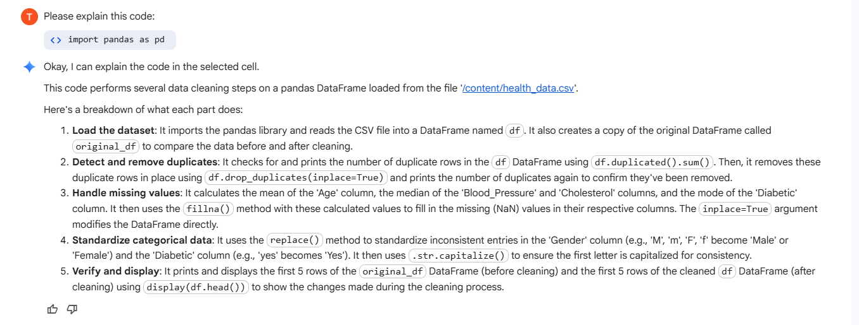

Question 2: AI-Assisted Data Preprocessing
Task:
You are provided with a dataset named customer_data.csv containing both numerical and categorical
features.
Use AI tools to generate a Python preprocessing script that performs:
1. Label Encoding or One-Hot Encoding for categorical variables.
2. Normalization or Standardization for numerical features.
3. Splitting the dataset into training and testing sets (80:20).

Instructions:
• Display statistical summaries (.describe() output) before and after preprocessing.
• Explain how the preprocessing steps can improve the performance of a machine learning model.
• Highlight any optimizations or corrections made based on AI tool recommendations.

CODE:
from sklearn.preprocessing import OneHotEncoder, StandardScaler
from sklearn.impute import SimpleImputer
from sklearn.model_selection import train_test_split
import numpy as np
import pandas as pd

# Load the data
df = pd.read_csv("/content/customer_data.csv")

# Identify categorical and numerical features
categorical_features = df.select_dtypes(include=['object', 'category']).columns
numerical_features = df.select_dtypes(include=['int64', 'float64']).columns

# Create copies to avoid modifying the original DataFrame
df_processed = df.copy()

# Impute missing values
# Impute numerical features with the mean
numerical_imputer = SimpleImputer(strategy='mean')
df_processed[numerical_features] = numerical_imputer.fit_transform(df_processed[numerical_features])

# Impute categorical features with the most frequent value
categorical_imputer = SimpleImputer(strategy='most_frequent')
df_processed[categorical_features] = categorical_imputer.fit_transform(df_processed[categorical_features])

# One-Hot Encode categorical features
encoder = OneHotEncoder(handle_unknown='ignore', sparse_output=False)
encoded_categorical_features = encoder.fit_transform(df_processed[categorical_features])
encoded_categorical_df = pd.DataFrame(encoded_categorical_features, columns=encoder.get_feature_names_out(categorical_features))

# Drop original categorical columns
df_processed = df_processed.drop(columns=categorical_features)

# Combine with encoded categorical features
df_processed = pd.concat([df_processed, encoded_categorical_df], axis=1)

# Scale numerical features
scaler = StandardScaler()
df_processed[numerical_features] = scaler.fit_transform(df_processed[numerical_features])

# Split the dataset
X = df_processed.drop('Customer_ID', axis=1) # Assuming 'Customer_ID' is not a feature for training
y = df_processed['Customer_ID'] # Assuming 'Customer_ID' is the target variable, replace if needed

X_train, X_test, y_train, y_test = train_test_split(X, y, test_size=0.2, random_state=42)

print("Training set shape:", X_train.shape)
print("Testing set shape:", X_test.shape)

OUTPUT :
Training set shape: (8, 11)
Testing set shape: (2, 11)

EXPLAINATION :
